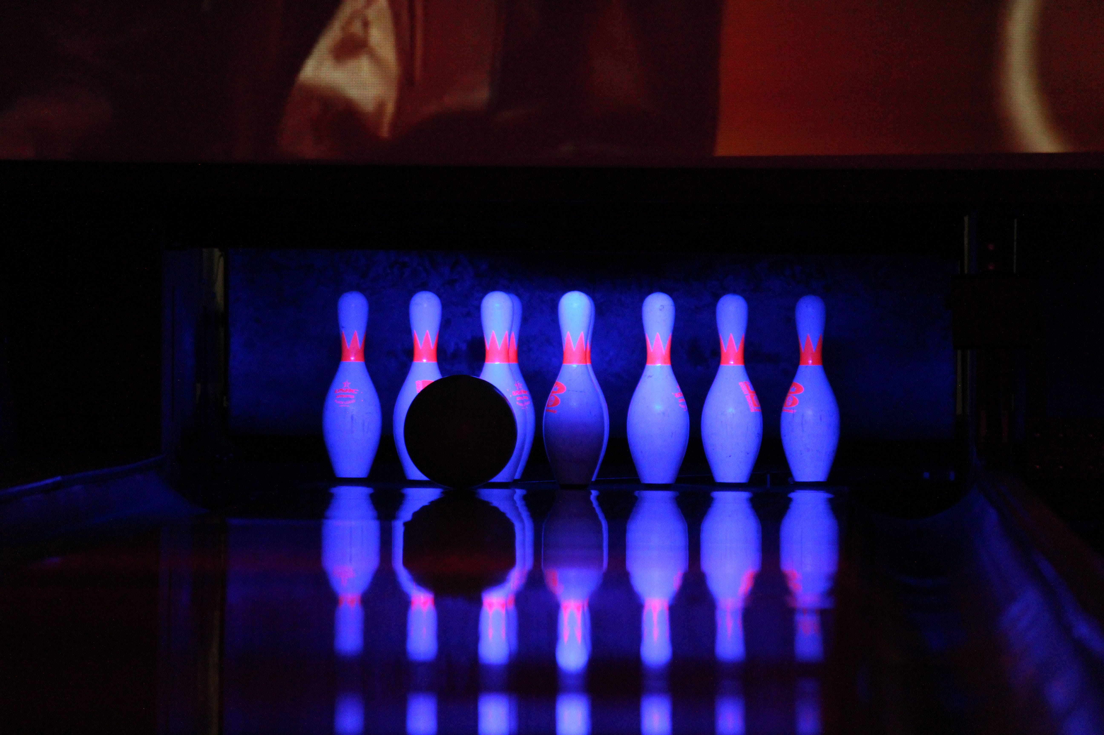
2nd Annual Coquitlam Open Invitational
Team/Doubles/Singles/All Events {optional}
January 6th/7th

Zone Bowling Centre
228 Schoolhouse Street, Coquitlam BC

ENTRY FEE: $40.00 PER PERSON PER EVENT
lineage $15.00 Prize Fund $24.50 Expenses $ .50
All Events $5 Each Extra
Prize money returned 100% Prize fund plus additional 50/50 sales and raffle/sponsors

*****************************************************************
Send Entries Austen Hack
626 Thompson Ave Coquitlam, BC V3J 3Z8 or
austenhack76@gmail.com
*************************************************
ENTRY FORM
Team Name:____________________
Saturday January 6th,2024
10:00am__________ 12:30pm___________ 3:30pm___________

Sunday January 7th, 2024
9:00am___________ 11:30am___________ 2:30pm___________
Circle Below
Bowler 1:________________________ Ave:_____ House Sport Challenge CTF#__________

Bowler 2:________________________ Ave:_____ House Sport Challenge CTF#__________

Bowler 3:________________________ Ave:_____ House Sport Challenge CTF#__________

Bowler 4:________________________ Ave:_____ House Sport Challenge CTF#__________

All Events Yes:________ No:__________ Scratch_______ Hdcp________

Captain contact Name:_____________________

Email: _____________________________ Phone:_________________

Address:_____________________________________________
City:________________________________________________

*** Lanes will be re dressed after 2nd shift each day, Limited Entries per shift

